Cody Hunter
Date submitted February 2nd, 2026
- Introduction
Project Goals:
The goal of this project is to provide an analysis of the air quality of the entirety of Nebraska to the client, UNMC Water, Climate, and Health Group. The client wants to understand how temperature, humidity, elevation, and location affect the quality of the air. The client has asked for 4 key tasks to be included in the final report; what are the five locations in Nebraska with the highest mean and median concentrations of VOC, PM 2.5 and PM 10.0, on what days did the maximum values occur and where did this maximums occur and what are some reasons, does humidity and temperature have a noticeable effect on air quality, and have there been any Air Quality health risks at any of the locations in the data provided by AirPurple for PM 2.5 and PM 10 based on the EPA’s ratings?

Project Tasks:
Task 1:
The first task was to find the five locations in Nebraska with the highest mean and median concentrations of VOC, PM 2.5, and PM 10.0. The first step was the filtering of the data to the parameters of VOC, PM 2.5, and PM 10.0. Next is to group the data by location by using the groupby(‘sensor.name’) function. Finally, was using the aggregate function to find the mean and median of the concentrations of each parameter. In order to understand the units given, PM and VOC were researched to fully understand what that data was referring to.
Task 2:
The second task was to analyze which days the maximum values occurred and where these maximums occurred. The task also requested to discover potential reasons why these maxima occurred. The first step to finding what day the maximum values occurred was to filter the parameters by VOC, PM 2.5, and PM 10.0 again. Next was to group the data by the date the readings occurred, and then take the aggregate function to find the maximums of the concentrations of the parameters. Then, going back to the filtered data, you can then group that by location and then take the maximums again. There is a little of research involved in this section as well because It will help with discovering what might be the reasons for those maxima.

Task 3:
The third task given is whether humidity and temperature have a noticeable effect on air quality. The first step would be to filter the data by the different categories of humidity by using less than or greater than functions, and by VOC, PM 2.5, and PM 10.0. Next would be to group by the monitor index and then use the aggregate function to find the max, min, mean, and median to see if humidity would have any effect on the concentrations. To find if temperature would have a noticeable effect the steps would be the same but instead of filtering by humidity into the different categories it would be filtering by temperature.

Task 4:
Task four is to determine whether there have been any Air Quality Index (AQI) health risks (unhealthy for sensitive populations) at any of the locations in the dataset for PM 2.5 and PM 10 based on the EPA’s AQI ratings. To find this out the coding steps would be to use a filter on the PM 2.5 and PM 10 when they are above a certain threshold. Then group the data by location, and then extract the date from the times that the values are above that threshold. The research that needs to be done would be to find out what the healthy thresholds are and what PM 2.5 and PM 10.0 mean. Then find out what might have happened on those days and locations to cause the increase in the particles in the air.

Task 5:
Task five is to determine if altitude has any effect on the amount of particles in the air. To find if it does have an effect on the air quality, first an equation needs to be defined to assign different altitudes to different categories of locations. Then that function will be applied to the data in order to sort the data. Finally the data will be compared to the different altitudes to see if there is an effect from altitude.

Deliverables:
The materials that the client has requested to receive at the end are the code that was used to find the data, A scope of work, an annotated code document, and a well-written report to summarize the results.

- Methods
Task 1:
First step was to group the data by the sensor name. Next was to find the mean and median of the types of data by using the aggregate function. After that, sort all of the data of the means and medians in descending order. Then return the highest 5 numbers.

Task 2:
First find the max values of the types of data sets in voc, pm 2.5, and pm 10.0. Next is to return the rows with the highest values. Then combine the results into one table and display the table.

Task 3:
The first step is to define a function for both humidity and temperature in order to classify the data into categories. Then apply the functions to the data set to classify the data into different categories for both temperature and percent humidity. Finally return the data in pivot tables to be able to compare the data.

Task 4:
Define functions for both pm 2.5 and pm 10.0 and then apply the functions to the data to classify the data into different concentrations of each particle. Then filter the rows by what data of the concentrations can be unhealthy for sensitive people and above. Finally combine the data of the unhealthy events and then display those rows.

Task 5:
First, define a function and assign it to the data to sort the different altitudes into categories. Then create a pivot table to be able to compare the results of the grouped data by altitude to see if there is a correlation between the amount of particles to altitude.

- Results and discussion section
  - Task 1:
    - Top 5 mean results of voc
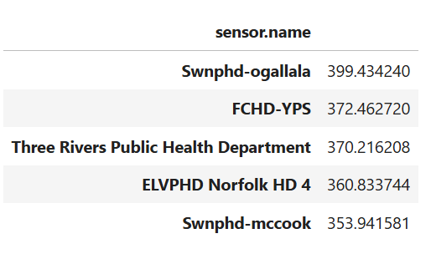
    - Top 5 median results of voc
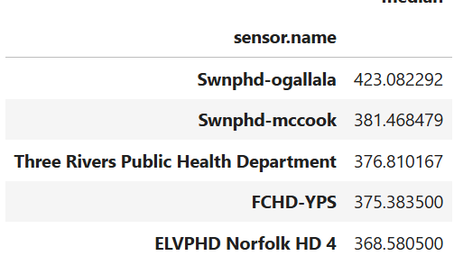
    - Top 5 mean results of pm 2.5
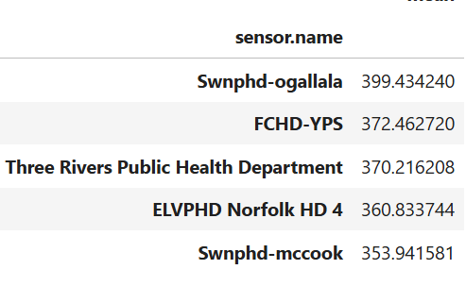
    - Top 5 median results of pm 2.5
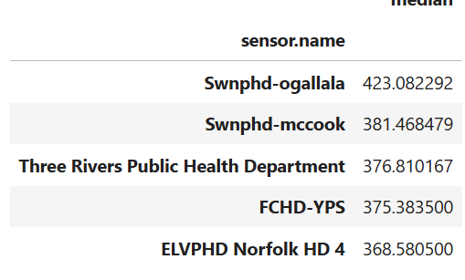
    - Top 5 mean results of pm 10.0
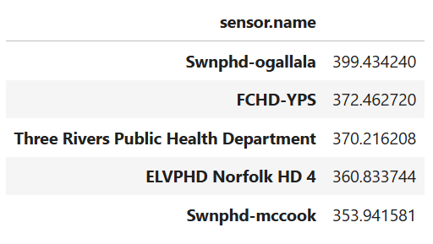
    - Top 5 median results of pm 10.0
      - 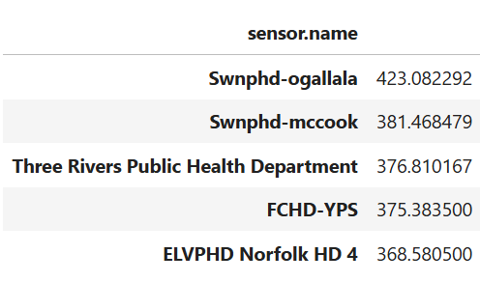
  - Task 2:
    - On what days did the maximum values occur and where did those maximum value occur?
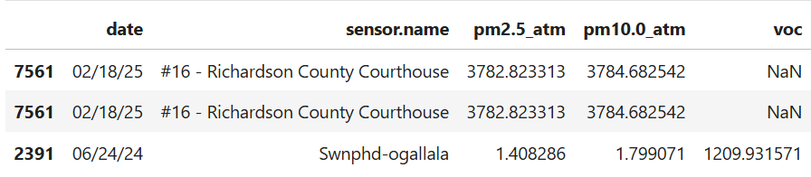
  - Task 3:
    - Does temperature and humidity have an effect on air quality?
    - 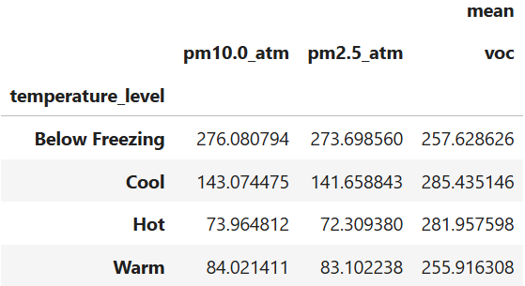
    - 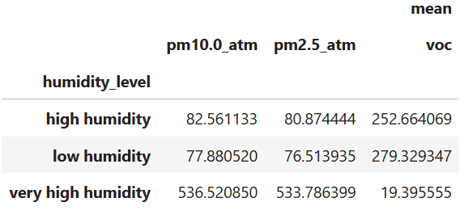
    - It appears that temperature does not have an effect on the air quality, but humidity does have an effect on the air quality. When humidity increases, PM 10.0 and pm 2.5 increase as well. When humidity increases voc decreases.
  - Task 4:
    - 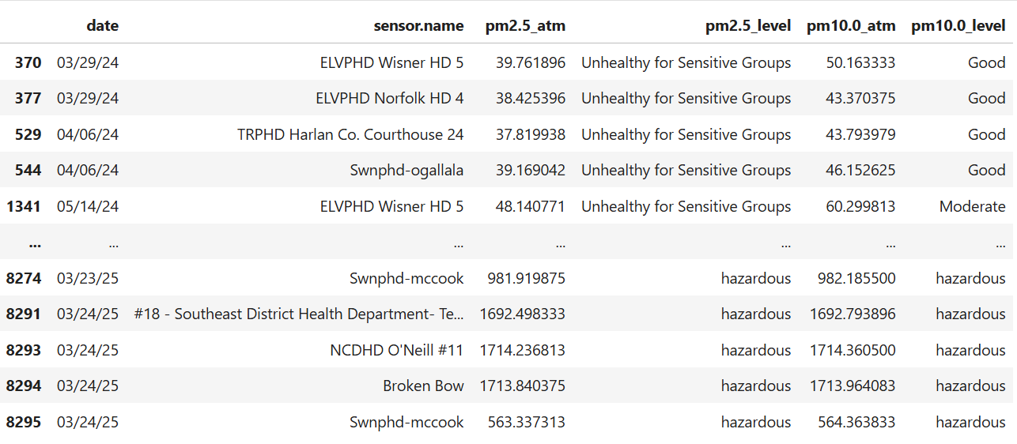
    - There are many different times when the air quality was or worse than Unhealthy for Sensitive Groups either for PM 2.5 or PM 10.0.
    - One of the events was in Broken Bow on March 24th, 2025 and this had a hazardous classification for both PM 2.5 and PM 10.0 because the power plant in Broken Bow exploded emitting a great amount of pollution and dust into the air.
  - Task 5:
    - Does altitude have an effect on air quality?
    - 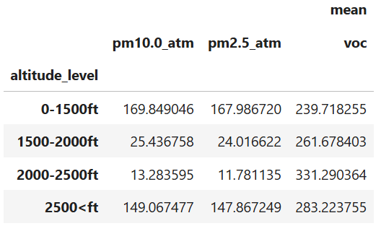
    - Using this data, the conclusion is that altitude does have an effect on air quality because at very high and low altitudes the PM 2.5 and PM 10.0 have high values, and at a range of 1500-2500 the voc is at a higher value.
- Reference list
  - Air Purple Map
    - US EPA PM2.5 Air Quality Standards Interactive Map by PurpleAir. (2026). PurpleAir; US EPA PM2.5 Air Quality Standards Interactive Map. https://map.purpleair.com/air-quality-standards-us-epa-aqi?opt=%2F1%2Flp%2Fa10%2Fp604800%2FcC0#5.21/40.002/-97.008
  - Purple Air Community
    - API. (2016). PurpleAir Community. https://community.purpleair.com/c/data/api/18
  - EPA Air Quality Tables
    - U.S. Environmental Protection Agency Office of Air Quality Planning and Standards Air Quality Assessment Division. (2018, September). Technical Assistance Document for the Reporting of Daily Air Quality – the Air Quality Index (AQI) [Review of Technical Assistance Document for the Reporting of Daily Air Quality – the Air Quality Index (AQI)]. https://uofnebraska-my.sharepoint.com/personal/37381171_nebraska_edu/_layouts/15/onedrive.aspx?id=%2Fpersonal%2F37381171%5Fnebraska%5Fedu%2FDocuments%2FTeaching%2FCIVE%20202%2FSpring%202026%2FProject%20%231%2FEPA%20Air%20Quality%20Index%20Document%2Epdf&parent=%2Fpersonal%2F37381171%5Fnebraska%5Fedu%2FDocuments%2FTeaching%2FCIVE%20202%2FSpring%202026%2FProject%20%231&ga=1
  - Air Now Website
    - AirNow. (2010). AirNow. Airnow.gov. https://www.airnow.gov/

